# Assignment 5

Deadline : 02/ 23/ 2018 24:00

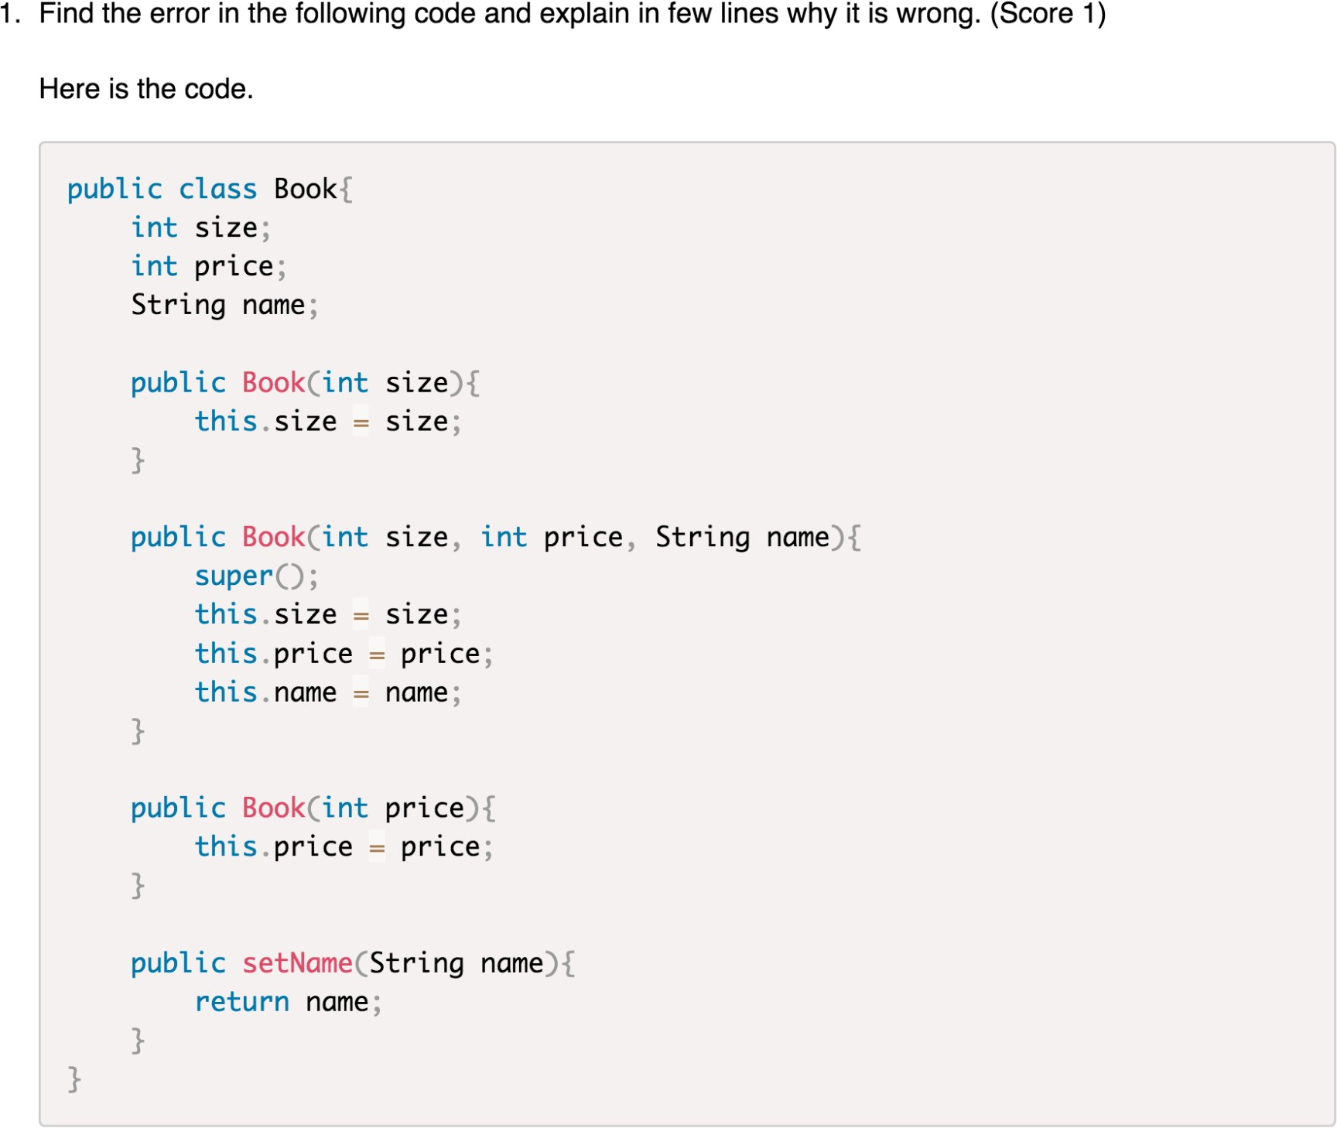

In this code:

1. There has two constructor of **Book(int x)**, when we declare and initialize a new object with one integer, it’s confusing for the compiler to know which constructor we use, whether the integer we type in refers to “size” or “price”, so **duplicate constructor is not allowed in Java**. In this case, we can change the datatype of price from “int” to “double”.
2. “SetName” is a non-static method but not a constructor, and the **return type** is required in method declaration. In this case, “public setName(String name)” should change to “public String setName(String name)”.

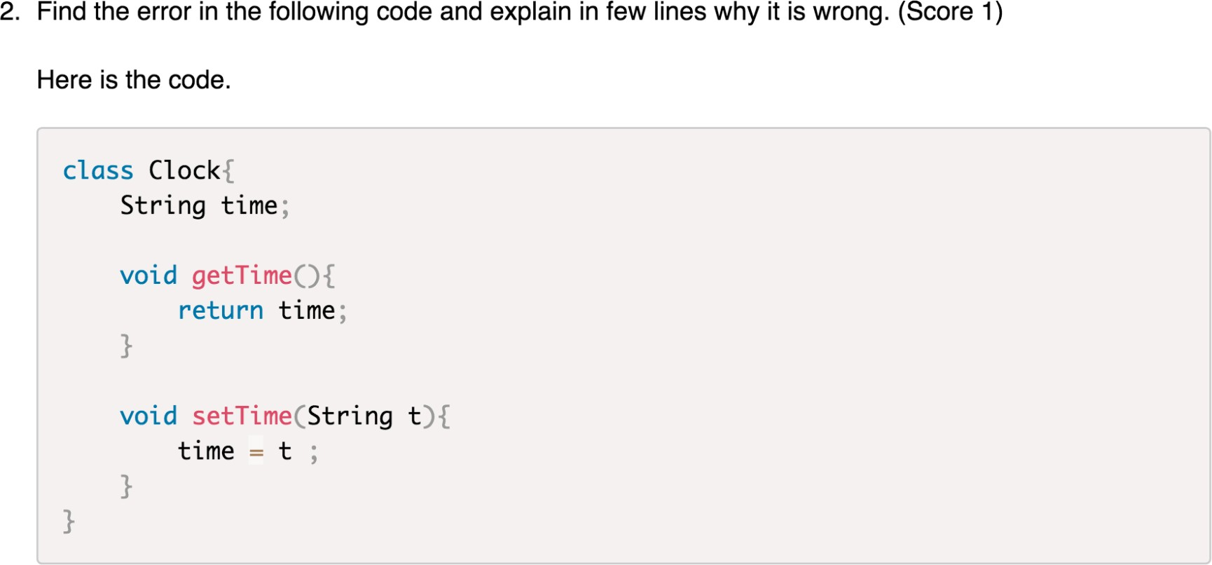

In this code:

The return type of method “getTime” is void, that’s mean it should not return anything in the method body, but it returns “time”. In this case, considering the function of method “getTime”, the return type should change from “void” to “String”.

1. (scores 2)
2. What will be the output of the following program?

The output will be:

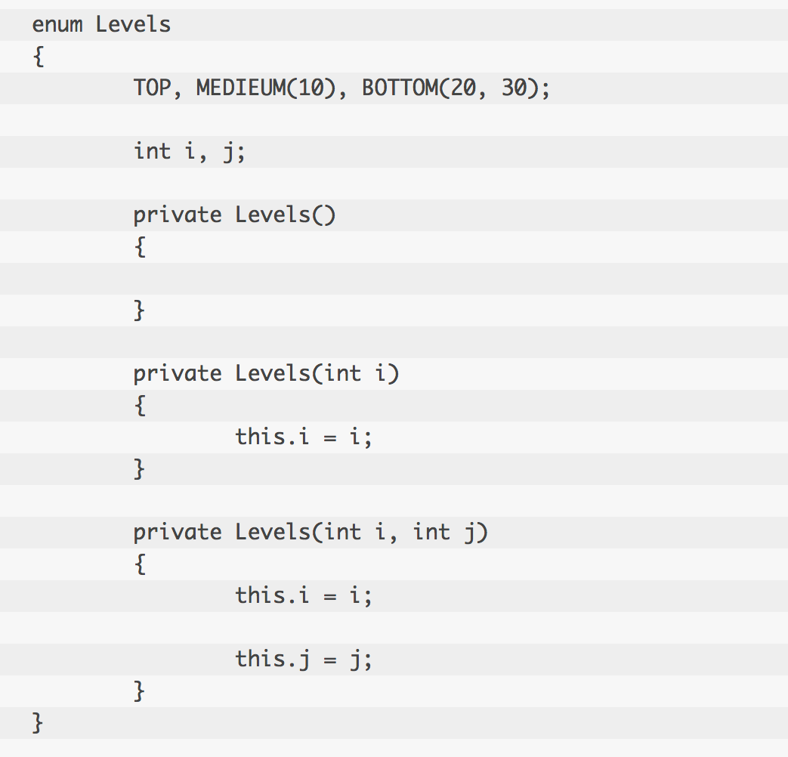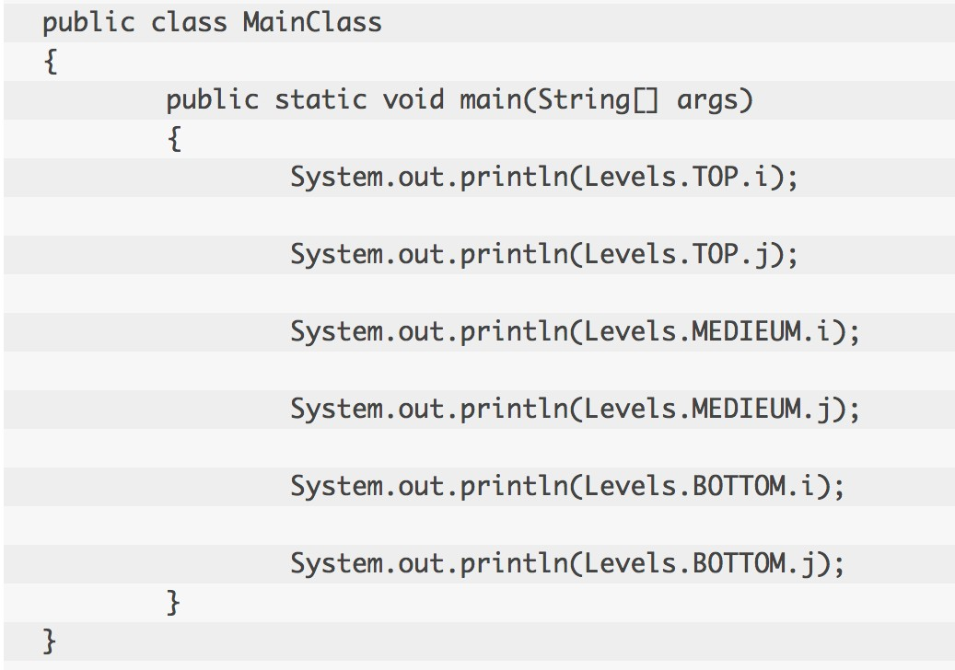

0

0

20

30

1. 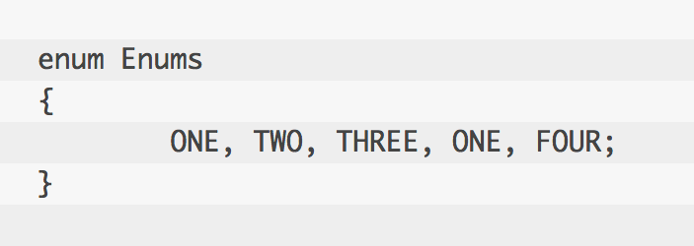Can you find out the error in the below code?

In this code, there has duplicate ONE, and since they belong to enum type, they are all constants, constants cannot have duplicate name.